**GroupScheduleWebApp UML Design Document**

Created by: S.A.F.; Skylar Cruz, Alberto Clara, Fabiane Young

10/21/18

**Activity Diagram**

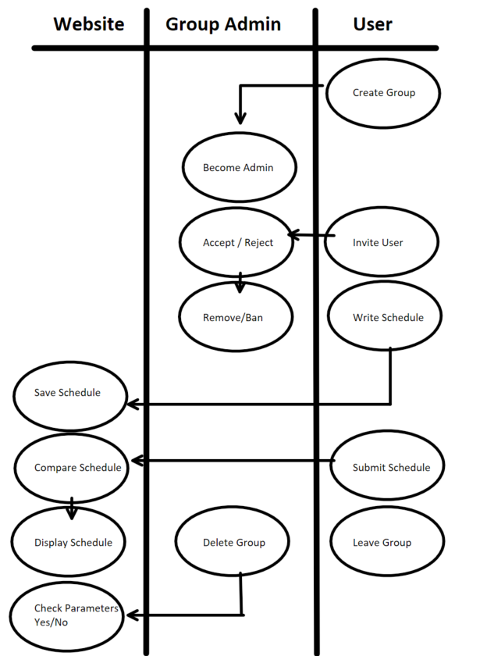

**Class Diagram**

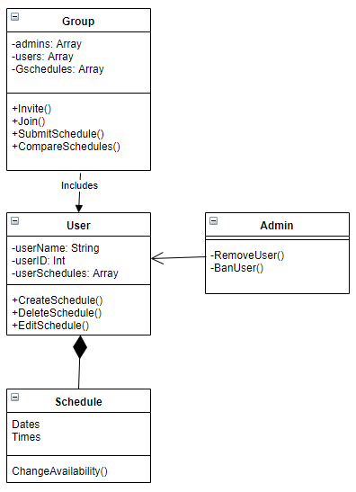

**State Diagram**

